Assignment:

There are three parts to this assignment, and is probably the most time-intensive of all your GDD Proposal Portions (but also one of the most interesting!). You will likely have two pages to turn in, containing:

1. Art Style:

Very simple. What is the style of your game? Is it cartoon-y or hyper-realistic? Very bright or dark and dingy? Positive or ominous, artsy or crude? Find any 2-4 images that represent the style you'd like to go for in your art design. In a few sentences, describe the style you're going for, and why it works for your game.

2. Level Map Description:

Please write a paragraph describing your map and its elements. What is the goal of the player in this area, or what will they gain upon completion? What happens at the key moments?

3. Level Map:

Create a legible game level, complete with all of the applicable criteria listed on the "Materials: Map Components" tab under the Assignments Focus Area of the website. Required of those elements:

Game Title, followed by Level Title

Level Type (You may use "level" broadly, if none of the other types qualify)

Map Key or Legend (or otherwise descriptors)

Pathways (Players and moving enemies)

Clear starting (or spawn) and exit/ending points, preferable labeled.

You must also, of course, create a visual map/area/level/wave/etc. This is an exceptional example, from "A Turtle War:"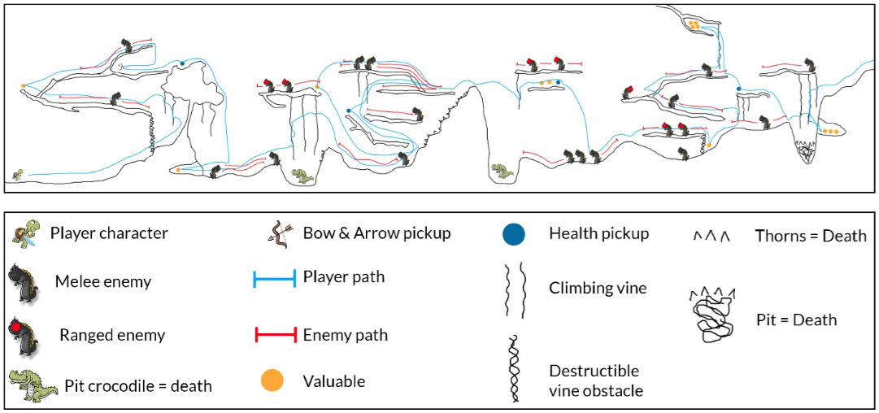

Part 1: Art Style (":Images" and ":Description")

2-4 images are included which highlight or exemplify desired art style of the game.

Images are clear, high-quality, and appropriately sized.

Description states how the art style reflects the mood of the game.

Part 2: Level Map Description

Map elements are described as needed. This includes a goal or reward, theme discussion, and actions (such as meeting enemies, or solving puzzles, etc). The question What do we do/gain here? is clearly answered.

Part 3: Level Map (":Contents" and ":Visual")

The Level Map contains all of the following required elements:

Game Title and Level Title

Level Type, if Applicable

Map Key or Legend

Pathways (For players and moving enemies)

Clear Start and End Points

The included map is legible, clear, well-designed, and is of appropriate size (50% to a full page). Landscape or portrait is fine.